GROUP THINK: THE COLLABORATIVE ART OF SLAVS AND TATARS AND CHTO DELAT?

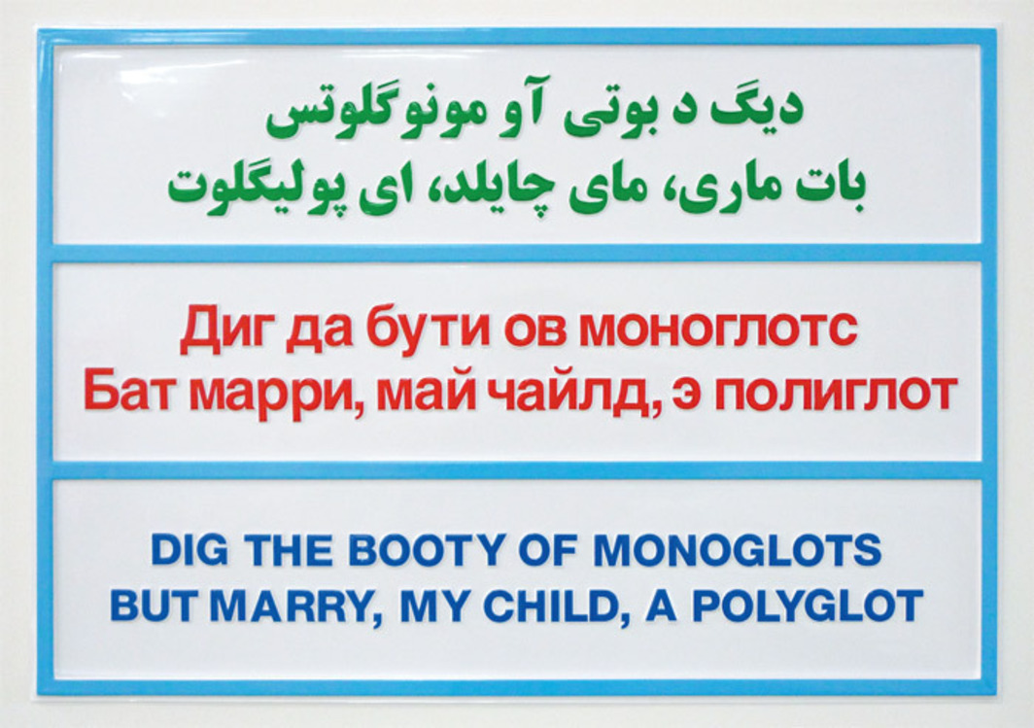
Slavs and Tatars, Dig the Booty, 2009, vacuum-formed plastic, 25 1/4 x 35 7/8".
MODERNITY, MONOBROWS, AND MONOTHEISM: These are just a few of the concerns of Slavs and Tatars, a collective dedicated to examining the region “east of the former Berlin Wall and west of the Great Wall of China,” as they so neatly put it. Founded in 2006 and consisting of an American, a Belgian, a Pole, and an Iranian raised in Texas, Slavs and Tatars aim to recuperate the history of exchange between Slavs, Caucasians, and Central Asians in the territory loosely known as Eurasia, which is, notably, the only area where Islam and the West have historically coexisted peaceably. The collective’s work spans various media—from installation, performances, and lectures to books and other printed matter—and encompasses cultural registers both high and low. Furthermore, their strident polemics are often embedded in Western-oriented modes of mass consumption, whether art, design, or fashion, so that the message is devoured long before its true, often oxymoronic meaning can be detected. Challenging notions of a dichotomy between East and West (exemplified by the Orientalism of eighteenth- and nineteenth-century Europe), Slavs and Tatars acknowledge difference but tease out the performativity within these cultural misunderstandings and mistranslations.
A brief résumé of the group’s recent activities would include countering the notion of Westernization as being synonymous with modernization; making T-shirts for Uniqlo and Parisian boutique Colette emblazoned with an on-trend antimodernist apothegm (NOUS SOMMES LES ANTI-MODERNES); mapping the transnational relationships, hidden interdependencies, and suppressed reciprocity of the oil industry’s Iran-Texas-Russia nexus; designing spreads for high-style culture glossy 032c; investigating Eurasianist attempts (including those of luminaries such as Roman Jakobson) to link, or rather lump, the Slavs with either the Turkic people or the Persians; and excavating the vexed history of the Azerbaijani (or Azeri) alphabet and its multiple flirtations with Arabic, Latin, and Cyrillic characters. Emboldened by collective authorship, the evocative collective (and eclectic) nouns of Slavs and Tatars function almost as a nom de plume, perhaps allowing for both a more caustic tone and a less abashed trendiness than might otherwise be possible (or at least comfortable) for a lone author. For Slavs and Tatars, collectivity is enshrined in their very name and is, arguably, largely responsible for their current cachet.
Indeed, the notoriety that groups such as Slavs and Tatars and their Russian counterpart Chto Delat? have so speedily earned suggests that even if artists’ collectives are not actually proliferating more than before, they are certainly gaining in traction. Following from the templates of the politicized collectives that came to prominence in the 1980s for their responses to the aids crisis (General Idea and Group Material), gender inequality (Guerrilla Girls), or the meltdown of Communist and totalitarian regimes in the Eastern bloc (Neue Slowenische Kunst), the possibilities afforded by the collective now seem to be as elastic as any given association’s potential membership. The past decade has seen fictitious collectives of one, such as the Atlas Group, and, at the other end of the spectrum, groups that pass themselves off as feigned solo artists (Claire Fontaine and Reena Spaulings); we have encountered twosomes that operate under the guise of a larger entity (the Otolith Group and Bureau d’Études) and, at the same time, a great many collectives scattered around the world that seemingly gain strength and visibility in numbers (Raqs Media Collective, Tercerunquinto, Raising Dust, Sędzia Główny [Chief Judge], Ultra-red, and Shahrzad Collective spring to mind here). Slavs and Tatars, on the other hand, as a sometimes fluctuating collective of four, happily occupy a middle—and perhaps more common—ground. In notable contrast to the smattering of examples provided above, where a unifying standpoint and a distinct voice for a small multitude are often embedded in the crucial cement of identity politics or rooted in genius loci, Slavs and Tatars seem to delight in jettisoning the usual rhetoric of collectivism. They are, instead, the most cosmopolitan of collectives, where a geopolitics of globe-trotting allows their shape-shifting projects and concerns to continuously cross-pollinate divergent, and sometimes diametrically opposed, cultural specificities.
Tackling problems of migration and mistranslation, especially as played out in Eurasia, Slavs and Tatars often take a linguistic approach, reflecting their origins as a peripatetic reading group that shifted between the various cities the members were based in, such as Brussels, London, and Moscow, and their early activities in translating and publishing. This linguistic bent is evident, for example, in Dig the Booty, 2009, a vacuum-formed plastic placard on which the invented (and unlikely) aphorism DIG THE BOOTY OF MONOGLOTS / BUT MARRY, MY CHILD, A POLYGOT, expressed in English using, of course, the Latin alphabet, also appears transliterated into Perso-Arabic script and Cyrillic to chart the vicissitudes of the Azeri language, whose official alphabet has over the past century shifted repeatedly among the three syllabaries by state decree. But the competing cultural claims represented by the various alphabets are trumped, in the end, by the wry fact that the phony adage appears in each of the Azeri alphabets but never in the Azeri language. An international Esperanto of appearance as opposed to meaning, not to mention our unthinking acceptance of English as the lingua franca, is the work’s real payoff. Slavs and Tatars’ recent project Kidnapping Mountains, 2009, took the form of both an exhibition and a publication (acting as a “repository of brutal ideas and romantic polemics,” in the group’s words) that chart the multitude of languages, ethnicities, and cultural identities covered by the collective’s geographic sweep while foregrounding their sardonic approach to geopolitics, with chapter headings such as “It’s Up to You, Baku” and “NATO: Nanny Approach to Others.” The exhibition, at Netwerk/Center for Contemporary Art in Aalst, Belgium, in 2009, took the topography of the Caucasus Mountains as its subject and consisted of sections of wood and mirrors crudely fitted together to form schematic peaks and slopes, which drew inspiration from the geometries of hand-cut Iranian mirror mosaics. Crucially, for Slavs and Tatars, within this vast territory, national and racial identity is fluid and often depends on one’s own perspective, as the description of the Caucasus as the “mountain of languages” implies, as does “Warm Siberia,” the nineteenth-century Russian sobriquet for the range.
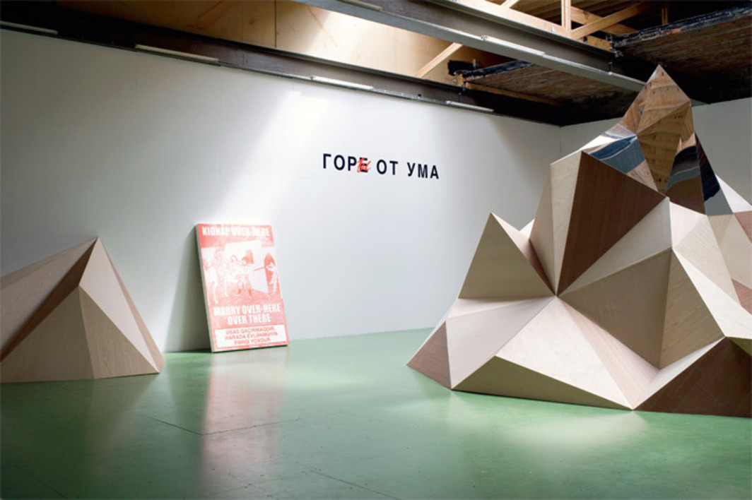
View of Slavs and Tatars, “Kidnapping Mountains, 2009, Netwerk/Center for Contemporary Art, Aalst, Belgium. Left: Kidnap Over-Here and Marry Over-Here Over There, 2008 (leaning against wall); Mountains from Wit, Woe from Wit, 2009 (wall application).
Craft imbued with revolutionary ideology is the focus of Resist Resisting God, 2009, a mirror mosaic (or “brutal bling,” as Slavs and Tatars christen it) that also pillages its form from the strict geometries of reflective mosaics found in royal residencies and Shiite shrines in Iran. These decorations originated in North Africa and were brought to Iran—where they persist to this day—during the Arab conquest in the seventh century, whereafter the Persians insisted on upping the ante and distinguishing themselves from the Arabs by upgrading the traditional materials of wood and ceramics to dazzlingly reflective mirrored glass. The embodiment of the migration of a technique, the work conjures the mysticism extolled by the revolutionary ideology of Tehran in 1979, while the deceptive title, with its double negative inscribed into the shiny surface, inverts the initial impression of blasphemy or atheism into a slogan that instead reaffirms spirituality. A critical spirituality also surfaces in the horrifically punning Hip to Be Square, 2010, which superimposes a screenprint of adjacent white and red rectangles, intended to recall both the Polish flag and one of the Suprematist compositions of Kazimir Malevich (whose Polish nationality is reclaimed here through the spelling of his name as Malewicz), onto the cover of a Huey Lewis and the News album from 1986; the band’s name has been crossed out and replaced with the signature of the mystical proponent of abstraction. Thus the sound track of advanced cold-war capitalism—1980s soft rock—is smuggled behind the iron curtain to be confronted by its historical, geographic, and political antithesis, the utopian, mystical, and futurological vision of the Russian avant-garde from around the time of the October Revolution. Style conquers content in Slavs and Tatars’ work, and Malevich’s complex (and occasionally incomprehensible) theories about the radical and transformative potential of nonobjective art are thus reduced and made to surrender to the totalizing effect of the ultimate linguistic commodity: the slogan.
Such creolizing is also exemplified in Slavs and Tatars’ floor piece When in Rome, 2010 (recently shown in “Between the Silhouette and the Background,” a group show in the titular city’s Galleria 1/9 Unosunove), in which the well-worn motto of social etiquette and cultural capitulation WHEN IN ROME DO AS THE ROMANS DO is chiseled into a travertine slab bearing a graffitied modification of ROMANS INTO ROMANIANS. Placed onto sections of enameled glass corresponding to the colors of the Gypsy flag, with euros scattered around it, the work thus becomes a monument to such slippage and hybridity, with a nod to the recent, and highly divisive, discussion over the true “place” of the Romany people in Italy and elsewhere in the European Union. The obverse and reverse of cultural norms were also explored in Slavs and Tatars’ project for the Frieze Sculpture Park in London last year, where they presented A Monobrow Manifesto—a giant green balloon installed on the grounds of Regent’s Park, decorated with the Janus faces of Bert from Sesame Street and an equally cartoonish stereotype of a swarthy Persian. The monobrow is thus deployed by Slavs and Tatars as an epiphenomenon that lays bare divergent social conventions and accepted wisdom on either side of the fault line between West and East. While in the former territory the unibrow, deemed unattractive, has been associated with brutishness, deviancy, character deficiencies, and even werewolves, in the Middle East it is a sign of manliness and refinement.
The muffling potential of the iron curtain is examined in Slavs and Tatars’ startling reworking of Western pop songs and standards in the ongoing project Hymns of No Resistance. This was initiated for Manifesta 7 in Bolzano, Italy, in 2008, where a banner hanging on the side of a building rejiggered the lyrics of George and Ira Gershwin’s “Let’s Call the Whole Thing Off.” Here, the litany of misunderstandings and minor disagreements over the “correct” pronunciation of words such as tomato was replaced by rather more divisive disputes mapped onto the loaded lexicons of radical Italian Marxism (YOU SAY AUTONOMIE, I SAY AUTONOMIA) AND IMMIGRATION (SO IF YOU LIKE EINWANDERER, AND I LIKE IMMIGRANTE). The liminal nature of South Tyrol in northern Italy, with its dual Italian and Germanic identities, allegiances, and languages, makes it, as Slavs and Tatars acknowledge, the perfect location and forum for such contentious debates. This project continued with a farcical retooling of Michael Sembello’s 1983 AOR power anthem and Flashdance sound-track hit “She’s a Maniac” into “She’s Armenian.” The reworked lyrics of the latter become a catchy take on ethnic tension as the struggles of an aspiring dancer from Pittsburgh are replaced by those of a fleeing diaspora Armenian. The song name-checks famous celebrities of Armenian extraction such as Atom Egoyan, Cher, Charles Aznavour, and Andre Agassi before reaching the payoff of the chorus: “She’s Ar-me-ni-an, Ar-me-ni-an, on the run. / And she’s fleeing but the flight has just begun.” Such transposition may owe something to Slavs and Tatars member Payam Sharifi’s experience growing up as an Iranian-American in Texas. Listening to the radio one day, he misheard the ’60s hit “Barbara Ann” as “Bomb Iran,” perhaps thinking that Vince Vance & the Valiants’ 1980 country-and-western hit of the latter title was a mere cover of the Beach Boys classic. Other pop songs have been similarly revised by Slavs and Tatars in their performances to become sound tracks to geopolitics and conflict within Eurasia: For instance, Rod Stewart’s “Young Turks” becomes, in their hands, “Young Kurds,” while Stealers Wheel’s “Stuck in the Middle with You” becomes a satiric lament about the recent Russian-Georgian conflict, “Stuck in Ossetia with You.” These are all performed by Berivan Kaya and the Orient Orchestra, a Kurdish ensemble that plays traditional string instruments, flutes, and drums. The Kurds, an oppressed people who constitute one of the largest ethnic groups without a nation, are indeed stuck in the middle of a region straddling Turkey, Iraq, Iran, and Syria. Here, as with other projects by Slavs and Tatars, the traditional collective methodology of agitprop is dispensed with and simply abbreviated to pop. These very literal transpositions and near-kitschy projects planted so firmly in the landscape of popular culture allow a generational shift to present itself, one that remembers that the fall of the Communist bloc, and the accelerated intermingling of ethnic and cultural identities that this process irrevocably set into motion, was in no small part facilitated by a transnational and voracious appetite for the comforting, lowest-common-denominator platitudes of mass culture. Viewed from this perpective, it is actually the songs of Rod Stewart and his ilk that carry the political punch in Slavs and Tatars’ karaoke of critique, rather than the parochial concerns of the new performers, who are subservient to the hackneyed popular tunes and simply pantomime them.
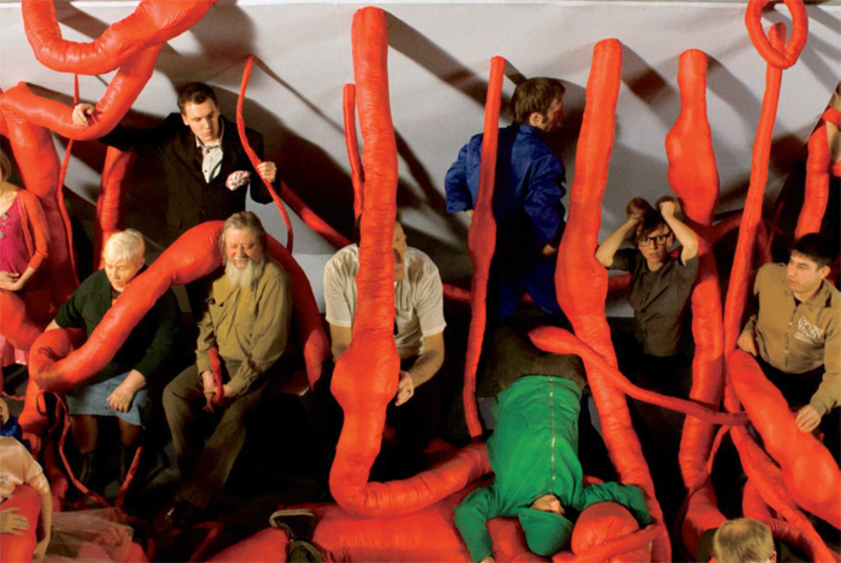
Chto Delat?, The Tower: A Songspiel, 2010, still from a color video, 36 minutes 52 seconds.
Slavs and Tatars’ recent expanded lecture 79.89.09, 2009–, revisits two key modern moments of insurgency—the Iranian Revolution of 1979 (considered by some to be the second most important date of the twentieth century after the Russian Revolution of 1917, marking, as it does, Islam’s confrontation with modernity), and Poland’s Solidarity movement of the 1980s and its imbrication in the collapse of Eastern-bloc Communism in 1989—and takes as its narrative strategy a reading of the recent past and the current geopolitical and ideological climate through the lens of these seemingly disparate but centrally transformative events. Part 1 of the collective’s ongoing series of performative talks titled “Friendship of Nations: Polish Shi’ite Showbiz” (which will be presented in its entirety at the Sharjah Biennial in the spring), 79.89.09 charts key moments in the unlikely solidarity of Poland and Iran, from Sarmatism in the seventeenth-century Polish-Lithuanian Commonwealth to Iran’s recent Green Movement. This wide-ranging yet somehow rhetorically coherent talk manages to take in the figure of Ali Shariati, who finessed an unlikely marriage of Marxism and Islam; the pervasive influence of Pope John Paul II and the Catholic Church, which was active in Communist Poland; the rise of apostasy in Poland and Iran (including recent conversions from Islam to Zoroastrianism); and the Slavs’ peculiar approach to duration: Time is never “spent,” as “duration has no dollar sign,” according to one member of the collective. This mix of temporality and Zoroastrianism also figures large in Slavs and Tatars’ 2008 project A Thirteenth Month Against Time, which pitches the ancient Jalali calendar (a version of which is used in Iran and Afghanistan to this day) against the more widely used (if arguably less accurate) Gregorian calendar. In Slavs and Tatars’ shrewd body of work, commodities such as alphanumeric systems, time and the way it is measured and counted, and the politics of duration are constantly pitted against one another to show the arbitrary nature of such ingrained cultural conventions.
IF SLAVS AND TATARS are sly and circumspect in their approach to geopolitics, the Russian group Chto Delat?, established in 2003 by a group of activists, artists, critics, philosophers, and writers from Saint Petersburg, Moscow, and Nizhny Novgorod, operate on a more earnestly political level. But both groups, whatever their differences in tone, have literary origins. Chto Delat?’s discursive modes of production and dissemination began with the (then unnamed) group’s first endeavor, a newspaper called Chto Delat? and an event located, as curator and critic Elena Filipovic has put it, “somewhere between a demonstration and an art performance.” Titled The Refoundation of Petersburg, the action was timed to coincide with, and act as pointed foil to the pomposity of, the official celebration marking the three hundredth anniversary of the city in 2003. Such English-Russian newspapers continue to be published by Chto Delat? to coincide with art-world activities such as exhibitions and conferences but also, crucially, for political rallies and demonstrations. The collective aim to merge seamlessly philosophy, political theory, art, and activism, and they draw inspiration from an array of sources, from Gustave Courbet to George Grosz to the Mexican muralists and, of course, the Russian avant-garde. To that end, Chto Delat? produce work in video, installations, public actions, radio programs, and artistic examinations of urban space, in addition to publishing their newspaper and operating a website, which means that all of the collective’s films and newspapers, and documentation of their installations and performances, are publicly accessible and available to download for free.
The name Chto Delat? (“What Is to Be Done?”) is borrowed from Nikolay Chernyshevsky’s 1863 novel, charting the rise of the first socialist workers’ organization in prerevolutionary Russia, and was famously taken up by Lenin in a 1902 call to arms that anatomized the relation between a revolutionary party and the working masses, as well as the role of the individual in the revolutionary process. “For us the reference to Chernyshevsky is much more important,” Chto Delat?’s Dmitry Vilensky observed in a 2008 interview with Gerald Raunig,
because at a certain moment in the late 1990s we found ourselves thrown back to the period of primitive accumulation of capital and confronted with new forms of labor slavery. In this situation, the development of left-wing movements paradoxically was comparable to the situation of the first Russian Marxist cells in the mid-nineteenth century. And Chernyshevsky’s novel was a brilliant attempt at writing some sort of a manual on how to construct emancipatory collectives and make them sustainable within a hostile society.
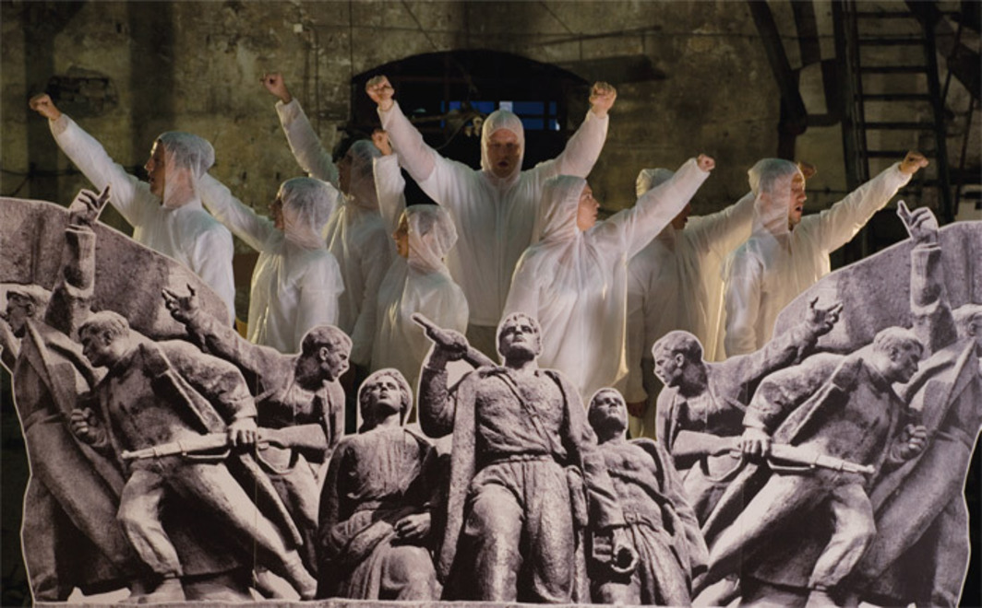
Chto Delat?, Partisan Songspiel: A Belgrade Story, 2009, still from a color video, 29 minutes 27 seconds.
Of course, this was not the first time that the group’s appellation has been used in the field of artistic inquiry. “What is to be done?” was one of the leitmotifs of Documenta 12 in 2007, while Mario Merz’s emblematic work of Arte Povera Che fare? (What Is to Be Done?), 1968, transposed Lenin’s polemic into a contemporary comment on the social upheaval that was occurring around the artist during the tumultuous events of that year. The creeping ubiquity of this phrase of late has caused the urgency supposedly contained in this central question of Marxist-Leninist political philosophy to become something of a cliché, reminding us that it is easier to just cite a problematic than to actually formulate an answer.
CHTO DELAT?’S INSTALLATIONS often take on the guise of the Gesamtkunstwerk. For example, “The Urgent Need to Struggle,” the group’s recent exhibition at the Institute of Contemporary Arts in London, comprised a series of display modules recalling the heady mix of utopianism and utilitarianism advocated by Russian Constructivist avant-garde designs, such as Aleksandr Rodchenko’s plans for a Workers’ Club, exhibited at the Exposition Internationale des Arts Décoratifs et Industriels Modernes in Paris in 1925. This loaded architectural framework was the setting for a series of Chto Delat?’s projections and films on monitors, including early works such as Angry Sandwichpeople or In Praise of Dialectics, 2005, in which the group marked the centennial of the Russian Revolution of 1905 by trying to repeat the “praise of dialectics” from Bertolt Brecht’s play Die Mutter (The Mother, 1930–31). Indeed, much of Chto Delat?’s work draws from Brecht’s maxim that art should both educate and entertain. Central to this commitment is the group’s trilogy of narrative films (termed Songspiels in reference to the form of musical theater devised by Brecht and Kurt Weill, which used popular song to deliver stringent critiques)—Perestroika Songspiel: The Victory over the Coup, 2008; Partisan Songspiel: A Belgrade Story, 2009; and The Tower: A Songspiel, 2010. Temporally situated in the upheavals and dramatic social changes of post-perestroika Russia and its orbit but firmly rooted ideologically in Marxian automatist principles of collectivism and self-organization, this last film takes Chto Delat? firmly back to where they began: Saint Petersburg. This fictive documentary follows the all-too-real plans of Gazprom, the enormous state-controlled energy company that has been one of the engines of Russia’s economic resurgence, to build a contentious seventy-seven-story skyscraper designed to loom over a city listed as a UNESCO World Heritage Site. In the film, a parodic board meeting, which takes place atop a makeshift platform, features schematic (and scheming) archetypes who enact the potential for art to be reduced to a fig leaf concealing the interests of big business. Among the sketchy characters represented in the video are an artist, an Orthodox priest, and a craven museum director who capitulates to the plans of the conglomerate in hopes of being rewarded with a center for contemporary art to be lodged somewhere in the building. Below these caricatures congregate the rabble, constituted by equally generic social stereotypes and differing factions, ranging from affirmative glamour girls to disaffected migrant workers to irascible radicals representing the last gasp of a once-potent left wing. As we cut between these two social milieus and as propaganda lurches into travesty, tentacle-like red protuberances begin to emerge and then engulf the hoi polloi below. Just as Slavs and Tatars’ mismatch of Malevich with Huey Lewis and the News makes manifest the abyss separating past and present artistic ambitions, Chto Delat?’s contemporary fable unflatteringly measures our distance from Russia’s Communist and futurological utopian vision as emblematized by Vladimir Tatlin’s models for his unrealized Monument to the Third International, 1919. The difference lies not just in the imperatives and intents behind the projects as respective symbols of Russia’s revolutionary moment and its capitulation to capitalism less than one hundred years later but also in the discrepancy between their ultimate fates: Tatlin’s tower, no matter the artist’s audacious vision, was never built, whereas Gazprom’s more or less conventional skyscraper has been endorsed by city authorities and is expected to proceed as planned. As Chto Delat? acknowledge, when it comes to Russia’s new order, not all voices are equal.
The Tower’s retro form of revolution was already evident in the slide-projection piece Builders, 2005, a restaging of Viktor Popkov’s 1960–61 socialist-realist painting The Builders of Bratsk. Here five workmen (and women) face the viewer directly as they take an obviously well-deserved cigarette break from their labors to seemingly contemplate the changes they are implementing to the society in which they work and the potentiality of such actions; the sound track presents a contemporary discussion about community. Yet such a sincere and straightforward homage to a work of post-Stalinist propaganda, however finely painted, is highly problematic. This lacuna between Chto Delat?’s model of the full revolutionary potential of the Soviet Union and the reality of post-perestroika Russia as it exists now, divided by the gulf of the slow failure of the Communist project in Russia over the course of the twentieth century (as evidenced by the group’s numerous works marking anniversaries in Russian history, such as the foundation of Saint Petersburg or the centenary of the 1905 revolution), is what both problematizes their work and gives it a much-needed sense of historical disjuncture. In Builders in particular, it is hard not to think that the “social” has been forced to stand in for socialism proper, even in a group as overtly politicized as Chto Delat? The pedagogical turn of the group is seen to full effect in works such as Drift: Narvskaya Zastava, 2004–2005, which charts the trajectory of a now-neglected district of Saint Petersburg through three pivotal moments: its playing host to decisive episodes in the Russian revolutions of 1905 and 1917; its regeneration during the 1920s as an administrative center under the new order, embellished with fine examples of Constructivist architecture; and its most recent incarnation as a ghetto dislocated from its eminent past and abandoned by the economic imperatives of deindustrialization and privatization in contemporary Russia. This history was excavated by Chto Delat? in a didactic research project of charting and mapping, which included both architectural historians and sociologists and was apparently implemented “with a Situationist dérive,” in a somewhat vague employment of the term.
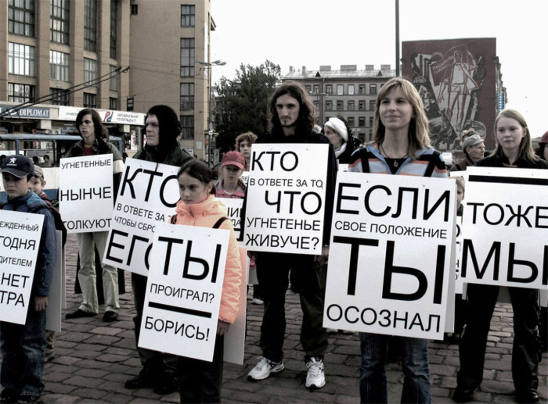
Chto Delat?, Angry Sandwichpeople or In Praise of Dialectics, 2005, still from a color video, 8 minutes.
If Chto Delat?’s insistence on “revolutionary art” feels nobly outmoded—and their nostalgic idealism strikes some critics as no less naive than their breathtakingly callow analysis of current social and economic conditions as analogous to those of czarist Russia—they nonetheless urgently seek to reactivate activism and to unleash the full potential of collectives through (to use their politically and ideologically freighted vocabulary) “solidarity,” “collectivism,” and a “different division of intellectual labor.” This last point highlights what some critics see as one of the key advantages of the group: “As a collective that vaunts the possibilities and particularities of collaborative authorship,” Filipovic has written in connection with Chto Delat?, “their endeavors bridge art, activism, and political theory with a membership that can expand or change depending on the needs of a specific project.
While Slavs and Tatars are mostly Westerners operating in the West and looking to the East (albeit still making work for a Western audience), Chto Delat? are Russians playing largely to the international art world from within Russia. Indeed, Chto Delat?’s efforts to make work that both confronts and transcends the conditions of national identity and cultural specificity have met with a mixed response, and this is often polarized, somewhat ironically, by geographic borders. As independent curator and critic Ekaterina Degot recently argued in the pages of this magazine, there is a marked difference between Chto Delat?’s reception in the West and at home: “Those who live in Russia cannot help but notice that the much-vaunted social activism of the group mostly takes place in and for the West, even if its latest work, The Tower: A Songspiel, 2010, addresses a local issue” (“A New Order,” Artforum, November 2010). Chto Delat?’s eagerness to associate themselves with the halcyon days of Communism and their “revolutionary” political zeal becomes more divisive as the group gain greater success in the Russian art world and abroad.
Beyond the possible fetishization of nationality and culture that responses, enthusiastic or otherwise, to these groups raise, Chto Delat?’s appropriation of the rhetoric and idealism of the early days of the Russian Revolution is noteworthy. At best nostalgic, at worst naive, Chto Delat?, like Slavs and Tatars, display a fascination bordering on yearning for prelapsarian Communism, but one wonders how this might sit with those who lived under the reality of the Communist regime in the countries whose history the collective purportedly seek to reclaim. As any Marxist worth his salt will remember, history repeats itself, first as tragedy, second as farce. The question of intentionality for Chto Delat?—and whether their recourse to a retrograde form of revolutionary potential is simply a well-meaning prod to their peers to remind them what has been lost as well as gained or, on the contrary, a simplistic desire to start from scratch and negate the most painful aspects of Soviet history—is one that must remain largely open-ended.
Both Chto Delat? and Slavs and Tatars raise pressing questions not just about their own collaborative practices and political credentials and allegiances but, more crucially, about the expanded art world in which they operate and which they must negotiate. At what point does polemical work that flaunts its political claims become radical chic, or a collective merely a clique? What is at stake in Slavic and post-Soviet reinterpretations of the collective in the wake of specific regional histories? Where do you draw the line between art that readily engages with an increasingly international context, recuperating differing cultural identities in the face of globalization, and work that merely panders (unintentionally or otherwise) to a rebranded form of neo-exoticism? Might a group that contains multiple ethnic viewpoints make for better biennial fodder, increasing its chances for inclusion and visibility at events often still based, at least in part, on nationhood and regional affiliation, from Berlin to Beijing and beyond? The possible answers to these questions are, it seems, as numerous as the fluctuating memberships of such multitudinous collectives.
Nicholas Cullinan is curator of international modern art at Tate Modern in London.

